Classic Packaging Industries

We, Classic Packaging specialize in,

.......Vacuum Forming Packing,

.......Blister Packing,

.......Skin Packing,

.......PVC Pouch Packing,

.......Pet Forming Tray,

.......Counter Display,

.......PVC Welding

OUR MACHINES

OUR MOULDS

Our packaging materials are most suited for food products, pharmaceutical goods, cosmetics, consumables, electronics, hardware, novelties, tools and toys.

Packaging is a crucial tool for sales & promotion. Better packaging half solves the problem of marketing.

We have a variety of packing solutions to choose from, we give all our customers individual attention to offer them competitive solutions. Today blister packing has been an all endorsing process. It covers almost all the packaging needs. It also remains our chief forte of success.

To innovate cost-effective solutions has been a constant process at Classic Packaging.

**Sliding Type Blister Packing**

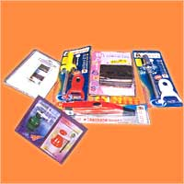

Here the pack is operable as the background paper board is not sealed it is just pushed in the pack. Where the three sides are just bent to hold the card. Customer can remove the card see or handle the product and again place the product inside the PVC Blister slide the card and the pack is closed. Used in Cutlery, Consumer goods, cosmetics, surgicals or pharmaceutical products, machine parts, etc.

**Vacuum Forming And Thermoforming Tray-Box For Fruit**

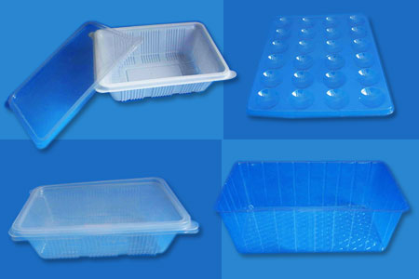

http://www.classicpackagingind.com/images/bullet.gif All Type Of Sizes And Design As Per Customer Requirement.  
  
http://www.classicpackagingind.com/images/bullet.gif Material of Construction : PVC / HIPS / PP / PET

**Vacuum Forming And Thermoforming Tray-Disposable Types Bowls**

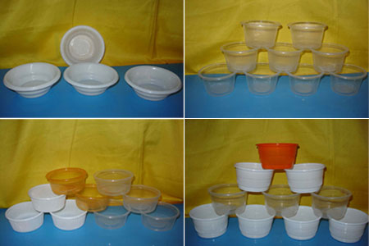

All Type Of Sizes And Design As Per Customer Requirement.  
  
http://www.classicpackagingind.com/images/bullet.gif Material of Construction: PVC / HIPS / PP / PET.

**Vacuum Forming And Thermoforming Drinking Cups**

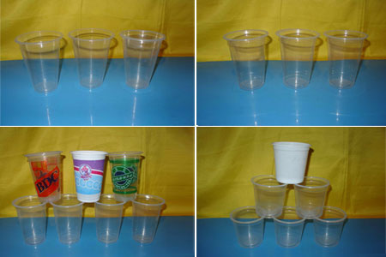

All Type Of Sizes And Design As Per Customer Requirement.  
  
http://www.classicpackagingind.com/images/bullet.gif Material of Construction: PVC / HIPS / PP / PET

**Vacuum Forming And Thermoforming Blister Packing For Bakery Products**

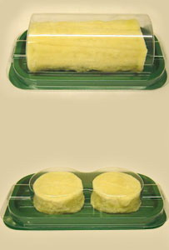

All Type Of Sizes And Design As Per Customer Requirement.  
  
http://www.classicpackagingind.com/images/bullet.gif Material of Construction : PVC / HIPS / PP / PET.

**Vacuum Forming And Thermoforming Blister Packing (tray) For Electronic**

**Parts & Tools**

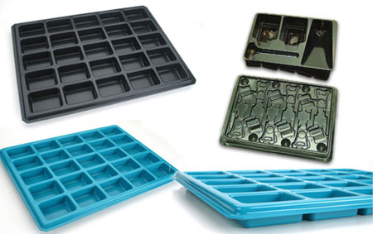

All Type Of Sizes And Design As Per Customer Requirement.  
  
http://www.classicpackagingind.com/images/bullet.gif Material of Construction : PVC / HIPS / PP / PET

**Vacuum Forming And Thermoforming Clamshells**

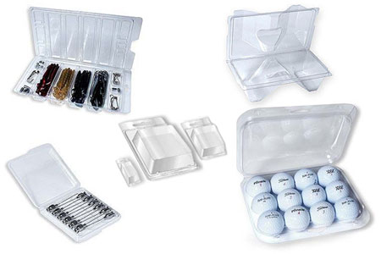

All Type Of Sizes And Design As Per Cu stomer Requirement.  
  
http://www.classicpackagingind.com/images/bullet.gif Material of Construction : PVC / HIPS / PP / PET.

**Vacuum Forming And Thermoforming Cosmetic Packing Tray**

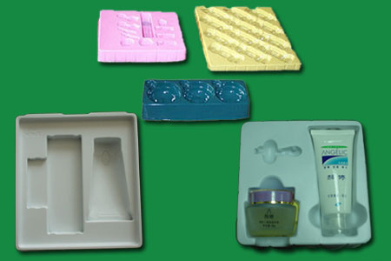

All Type Of Sizes And Design As Per Customer Requirement.  
  
http://www.classicpackagingind.com/images/bullet.gif Material of Construction : PVC / HIPS / PP / PET.

**Vacuum Forming And Thermoforming Heat Sealed Blister Packing**

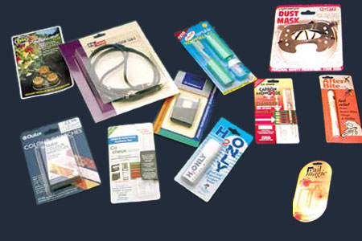

 All Type Of Sizes And Design As Per Customer Requirement.  
  
http://www.classicpackagingind.com/images/bullet.gif Material of Construction : PVC / PET.

**Vacuum Forming And Thermoforming Heat Sealed Blister Packing**

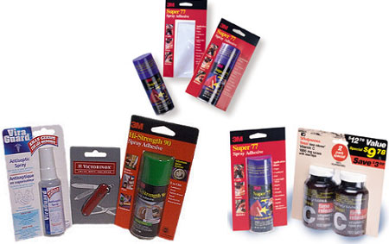

All Type Of Sizes And Design As Per Customer Requirement.  
  
http://www.classicpackagingind.com/images/bullet.gif Material of Construction : PVC / PET.

**Disposable Plates**

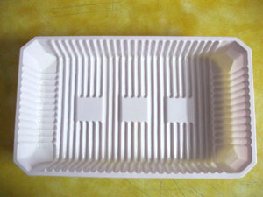 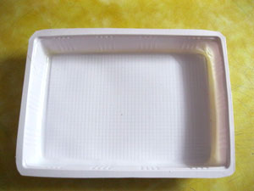

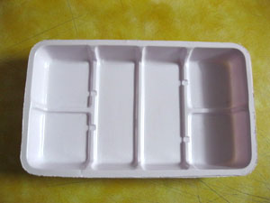

**Egg Tray Disposable**

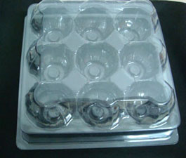 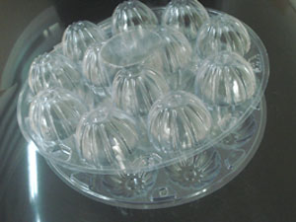

**Disposable Tray**

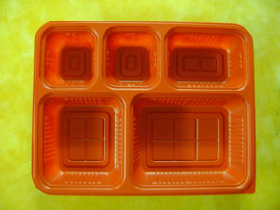 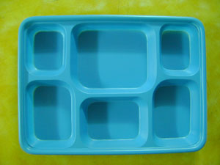

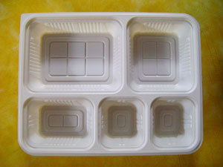 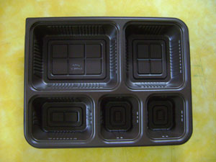

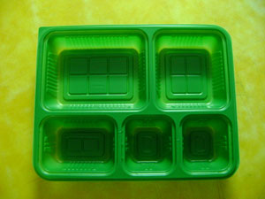 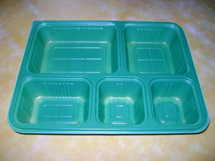

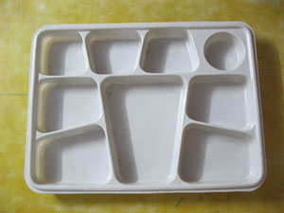 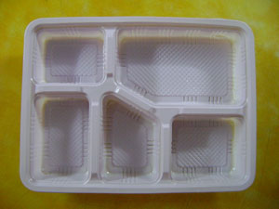

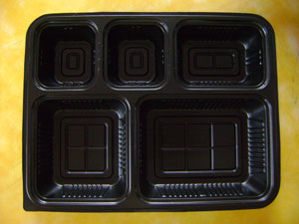 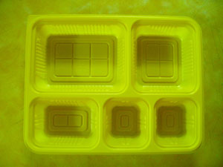

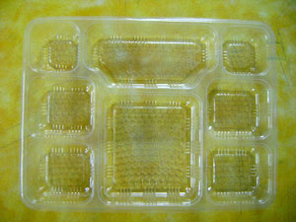 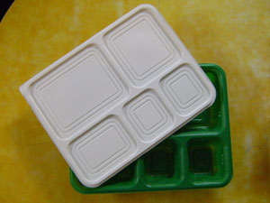

**Fish Tray**

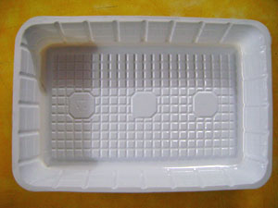 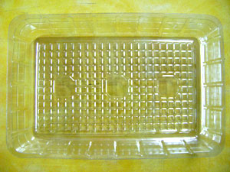

**Disposable Food Tray**

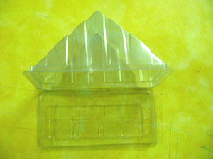 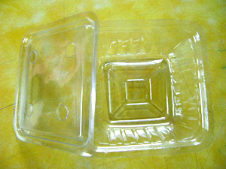

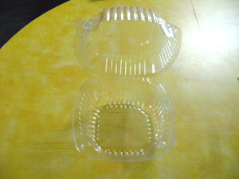 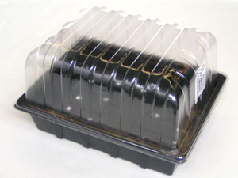

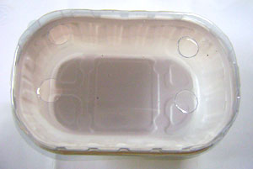 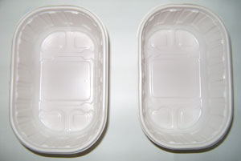

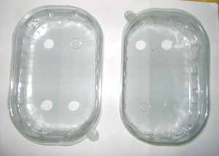

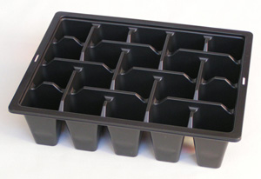 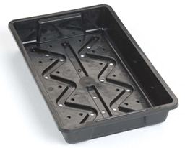

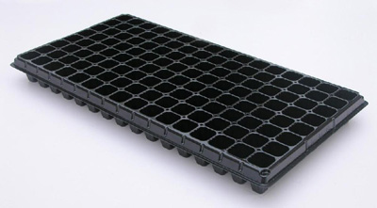

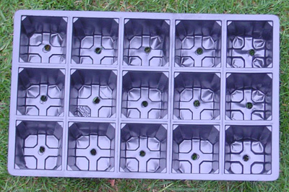

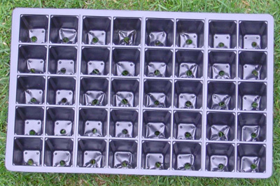

**Vacuum Forming And Thermoforming Sliding Type Blister Packing**

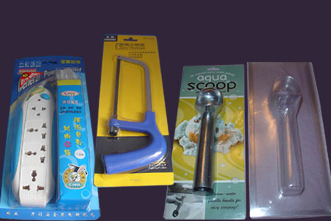

All Type Of Sizes And Design As Per Customer Requirement.  
  
http://www.classicpackagingind.com/images/bullet.gif Material of Construction : PVC / PET.

**Vacuum Forming And Thermoforming Threefold Clampshell Blister Packing**

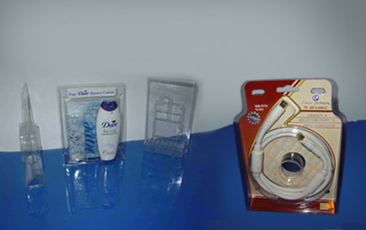

All Type Of Sizes And Design As Per Customer Requirement.  
  
http://www.classicpackagingind.com/images/bullet.gif Material of Construction : PVC / PET.

**Vacuum Forming And Thermoforming Tray For Computer Accessories**

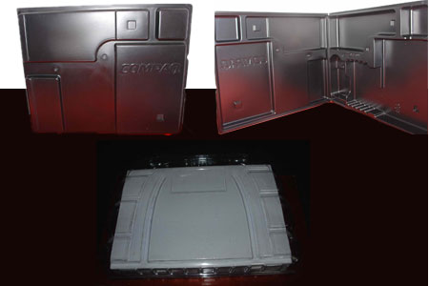

All Type Of Sizes And Design As Per Customer Requirement.  
  
http://www.classicpackagingind.com/images/bullet.gif Material of Construction : PVC / HIPS / PP / PET.

**Vacuum Forming And Thermoforming Tray For Pharmaceuticals**

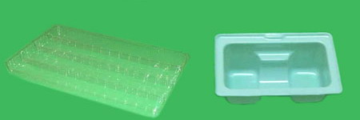

All Type Of Sizes And Design As Per product Requirement.  
  
http://www.classicpackagingind.com/images/bullet.gif Material of Construction : PVC / HIPS / PP / PET.

**Vacuum Forming And Thermoforming Blister Packing (Tray) For Toys**

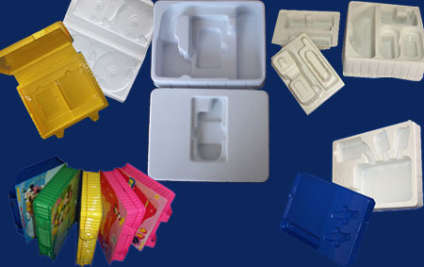

All Type Of Sizes And Design As Per Customer Requirement.  
  
http://www.classicpackagingind.com/images/bullet.gif Material of Construction : PVC / HIPS / PP / PET.

**Vacuum Forming And Thermoforming Blister Packing For Batteries**

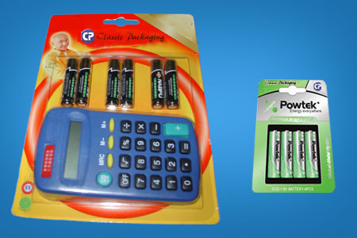

All Type Of Sizes And Design As Per Customer Requirement.  
  
http://www.classicpackagingind.com/images/bullet.gif Material of Construction : PVC / HIPS / PP / PET.

**Vacuum Forming And Thermoforming Cups**

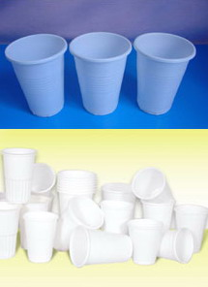

All Type Of Sizes And Design As Per Customer Requirement.  
  
http://www.classicpackagingind.com/images/bullet.gif Material of Construction : PVC / HIPS / PP / PET.

**Vacuum Forming And Thermoforming Cups & Lids**

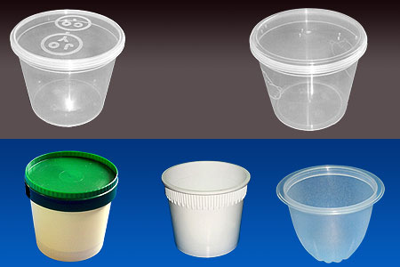

Sizes available : 50ml - 500ml.  
  
http://www.classicpackagingind.com/images/bullet.gif Diameter : 76mm - 120mm.  
  
http://www.classicpackagingind.com/images/bullet.gif Material of Construction : PVC / HIPS / PP / PET.

**Vacuum Forming And Thermoforming Tray & Plates**



All Type Of Sizes And Design As Per Customer Requirement.  
  
http://www.classicpackagingind.com/images/bullet.gif Material of Construction : PVC / HIPS / PP / PET.

**Vacuum Forming And Thermoforming Tray & Box For Fast Food & Sandwitch**

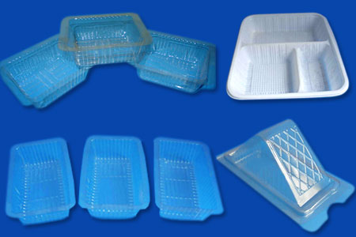

All Type Of Sizes And Design As Per Customer Requirement.  
  
http://www.classicpackagingind.com/images/bullet.gif Material of Construction: PVC / HIPS / PP / PET.

**Vacuum Forming And Thermoforming Tray Disposable Types Containers**

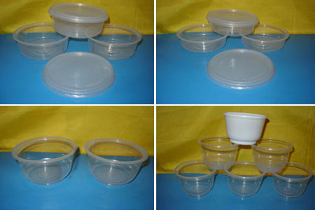

All Type Of Sizes And Design As Per Customer Requirement.  
  
http://www.classicpackagingind.com/images/bullet.gif Material of Construction : PVC / HIPS / PP / PET.

**Cfl Packaging**

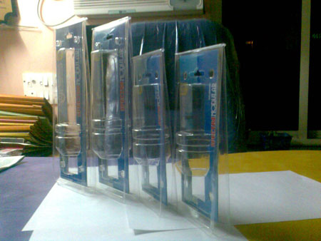

**Vacuum Forming And Thermoforming - Blister Packing**

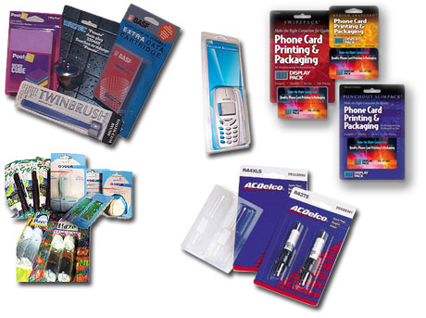

All Type Of Sizes And Design As Per product Requirement.  
  
http://www.classicpackagingind.com/images/bullet.gif Material of Construction : PVC / HIPS / PP / PET.

**Vacuum Forming And Thermoforming Cosmetic Display Holder**

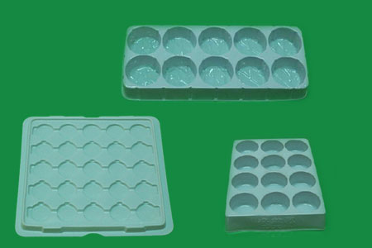

All Type Of Sizes And Design As Per Customer Requirement.  
  
http://www.classicpackagingind.com/images/bullet.gif Material of Construction : PVC / HIPS / PP / PET.

**Vacuum Forming And Thermoforming Flocking Trays For Stationery & Surgicals**

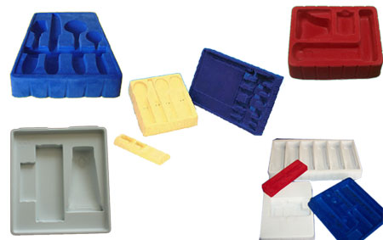

**Vacuum Forming And Thermoforming Flocking Trays For Toys & Cutllery**

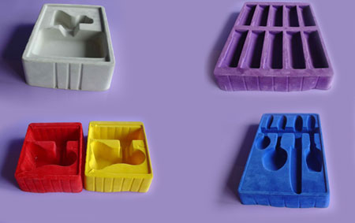

All Type Of Sizes And Design As Per Customer Requirement.  
  
http://www.classicpackagingind.com/images/bullet.gif Material of Construction : PVC / HIPS / PP / PET.

**Vacuum Forming And Thermoforming Heat Sealed Blister Packing For PVC Paper**

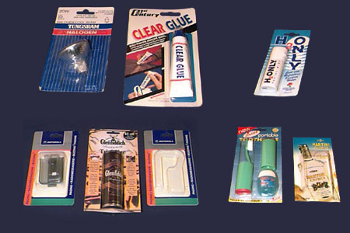

All Type Of Sizes And Design As Per Customer Requirement.  
  
http://www.classicpackagingind.com/images/bullet.gif Material of Construction : PVC / PET.

**Our Machines**

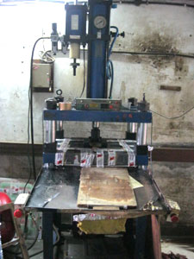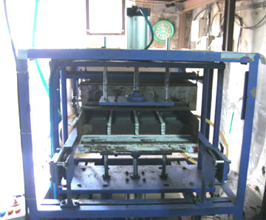

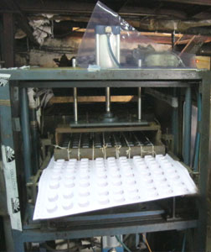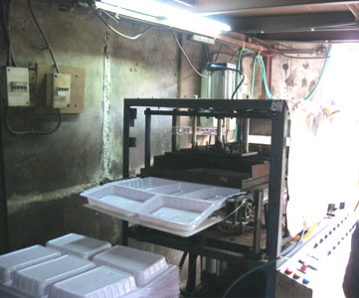

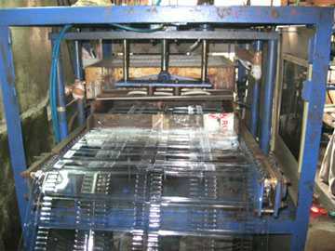

**Our Moulds**

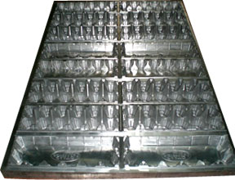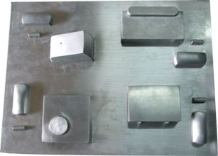

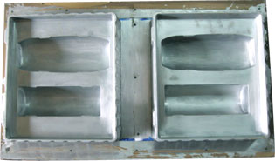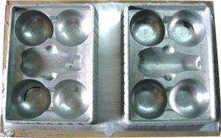

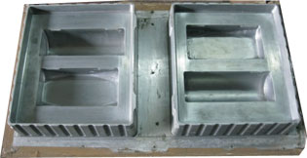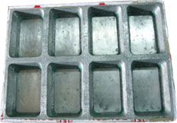

**Blister Packaging using Thermoforming Technique**  
  
**Blister pack** is a term for several types of pre-formed plastic packaging used for small consumer goods, foods, and for pharmaceuticals.  
  
The primary component of a blister pack is a cavity or pocket made from a "formable" web, usually a thermoformed plastic. This usually has a backing of paperboard or a "lidding" seal of aluminum foil or plastic. A blister that folds onto itself is often called a **Clamshell**.  
  
**Thermoforming** is a manufacturing process where a plastic sheet is heated to a pliable forming temperature, formed to a specific shape in a mold, and trimmed to create a usable product. The sheet, or "film" when referring to thinner gauges and certain material types, is heated in an oven to a high-enough temperature that it can be stretched into or onto a mold and cooled to a finished shape.

OFFSET PRINTING

**Offset Printing is great for:**business cards, letterhead, catalogs, books/booklets, business forms, flyers, brochures, calendars, invitations and so much more.

Offset printing offers the best price per piece in the printing industry.

It is also the highest quality printing process in the industry. The process produces prints with rich, smooth solids without the streaking found in lesser quality prints. Actual inks are used, not toner. The look and feel of any offset product comes across as more professional.

## Vacuum Forming:

Vacuum forming is a very common type of plastic forming and many plastic products have been vacuum formed - such as packaging inside a box which needs to fit the product. The animation and explanation below shows the basic process involved, for high speed, more detailed and mass produced the process uses more complicated hydraulic and heat controls.